Elevator Safety
DO NOT OVERLOAD ELEVATORS!
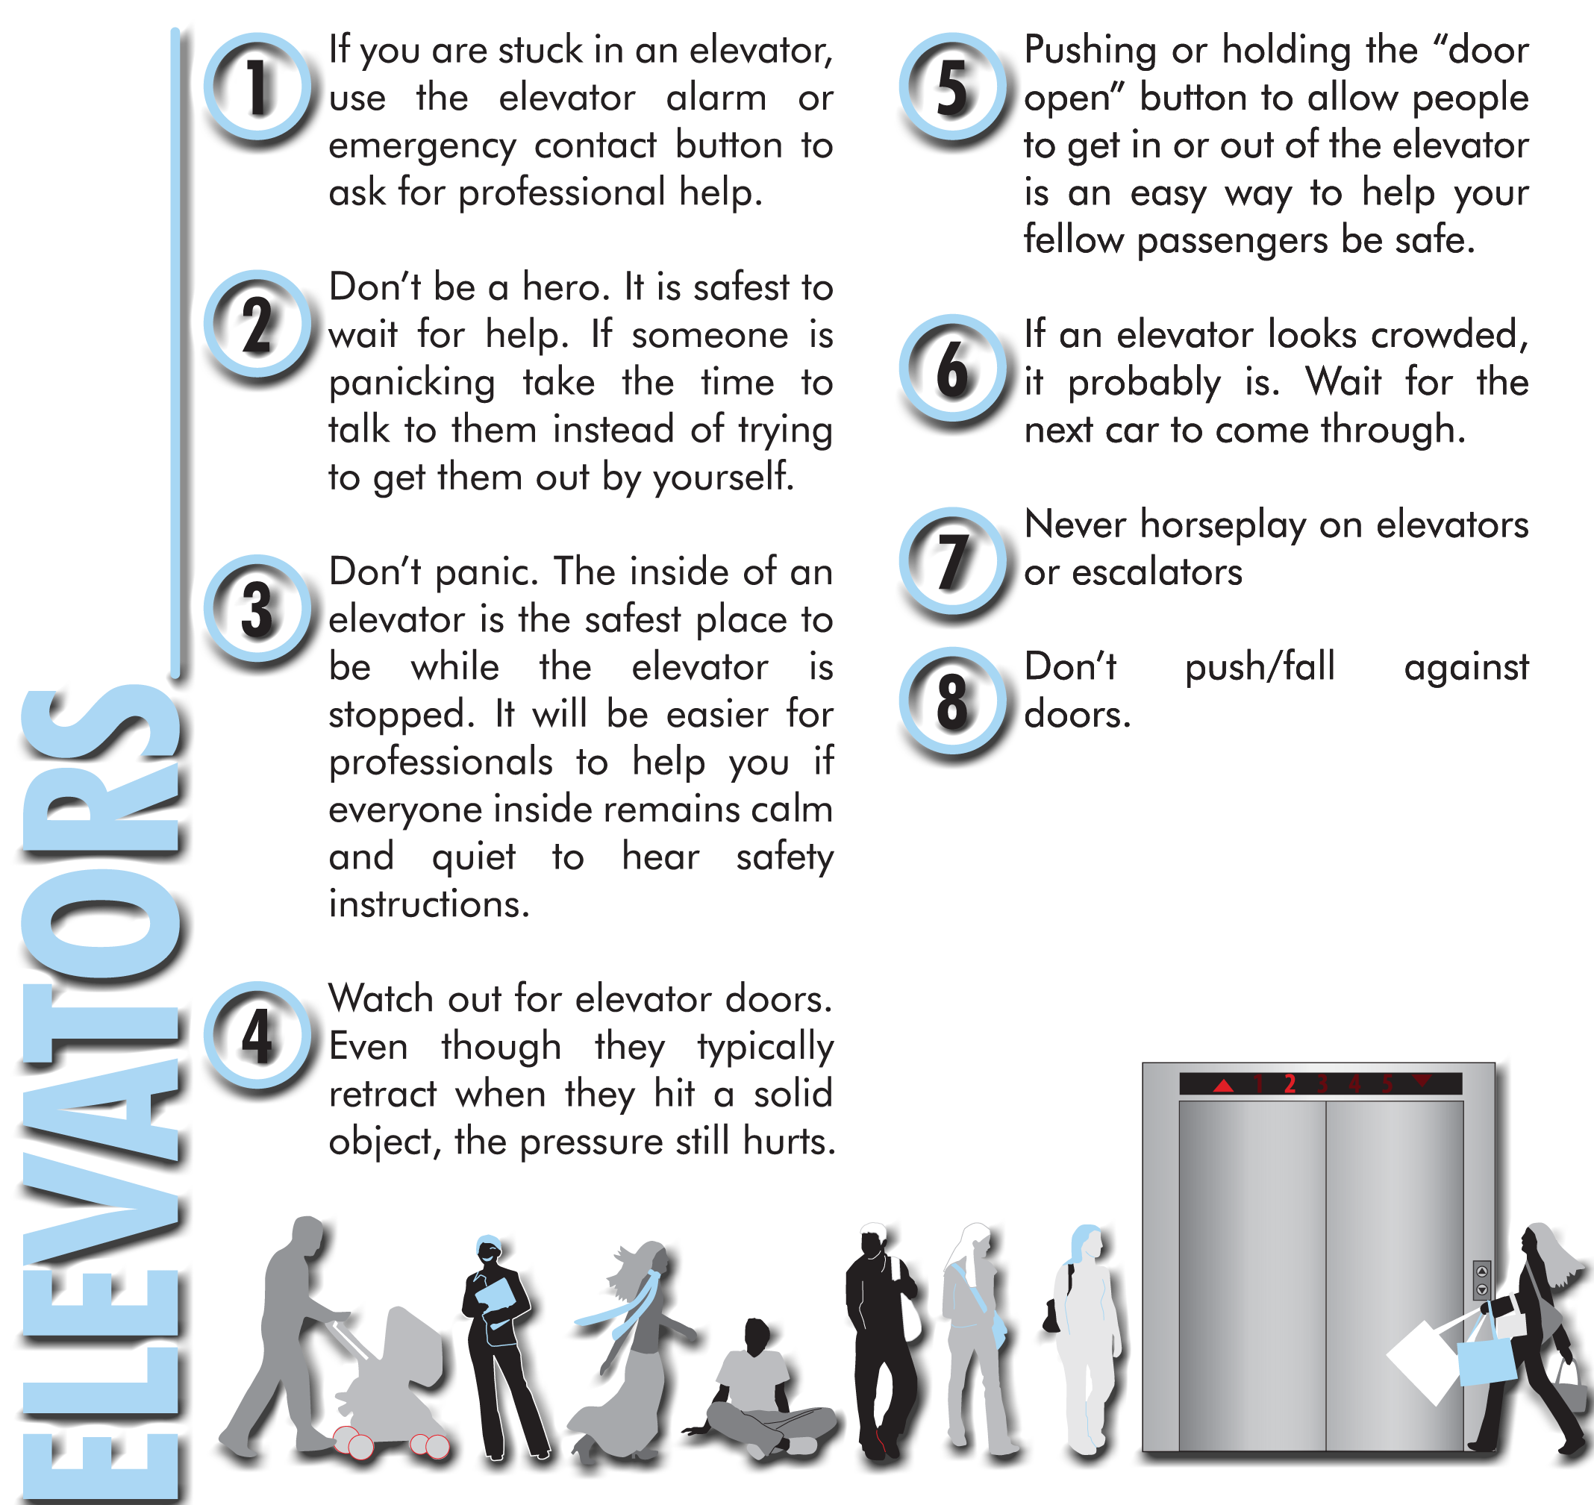
In The Event of an Emergency Call Security/Safety:
123-456-7890

Elevator Don’ts!
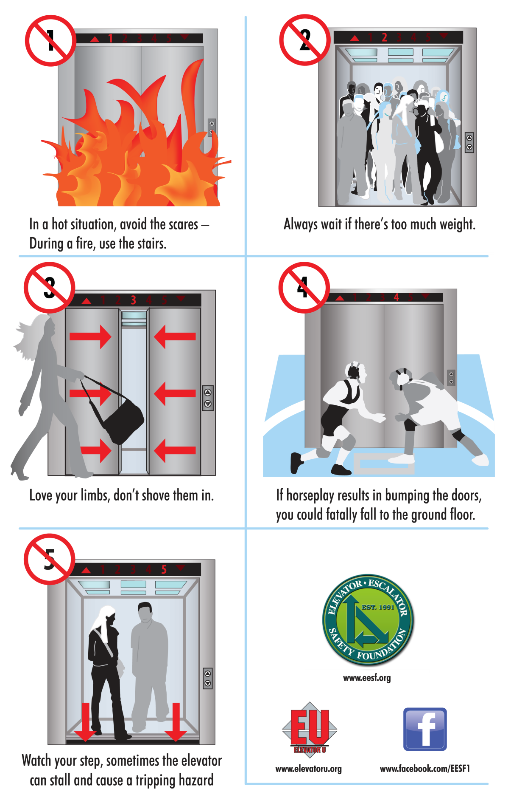
In The Event of an Emergency Call Security/Safety: 123-456-78910

